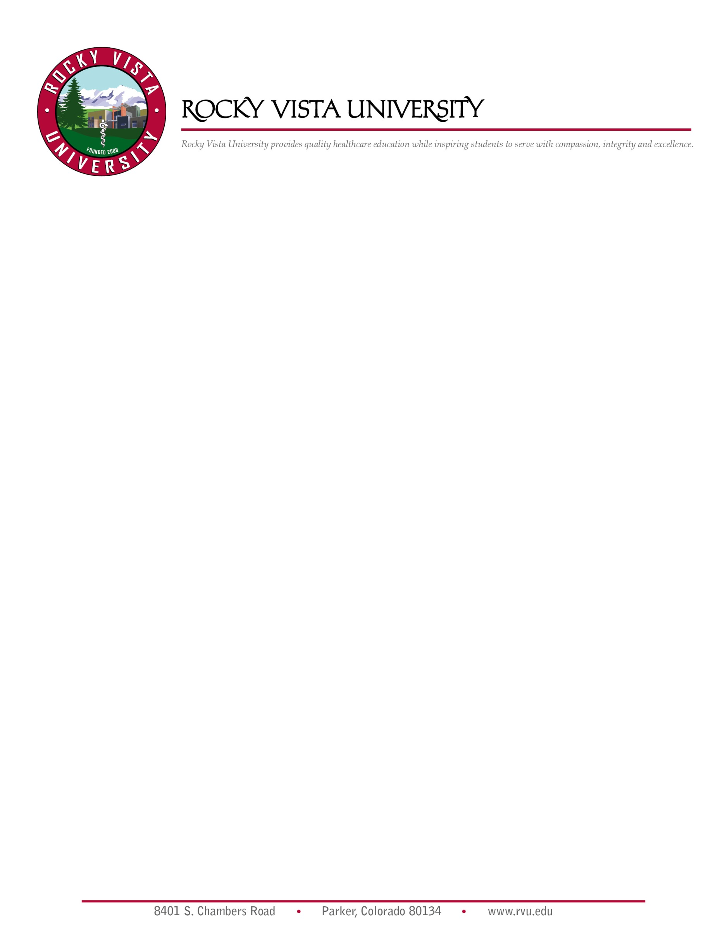

Explanation of Victims’ Rights
RVU will assist victims of sexual assault, domestic violence, and stalking and will provide each victim with a written explanation of their rights.
In both Colorado and Utah, a victim of domestic violence, dating violence, sexual assault or stalking has the following rights: treatment with fairness, respect and dignity, information on all charges filed and assurance of swift and fair resolution of the proceeding, notification of any change in the status of the accused, input into decisions regarding plea bargains, and to be present and to have input into sentencing and parole hearings, restitution or civil remedy, release of property after the case is settled and it is no longer needed as evidence, be informed about what steps can be taken if he or she is subjected to intimidation or harassment, employer intercession, notification of all case dispositions including appeals, timely notification of all court dates, translation services, intervention with creditors, landlords and employers, legal resources, rehabilitative services, transportation and child care services, information about obtaining public records, including police reports, information about protective orders. Further, Rocky Vista University complies with Colorado and Utah law in recognizing orders of protection by:

Any person who obtains an order of protection from Colorado, Utah, or any reciprocal state (Alabama, Alaska, Arizona, Arkansas, Delaware, Florida, Georgia, Idaho, Indiana, Iowa, Kansas, Kentucky, Louisiana, Michigan, Mississippi, Missouri, Montana, Nebraska, New Hampshire, New Mexico, North Carolina, North Dakota, Oklahoma, Pennsylvania, South Dakota, Tennessee, Texas, West Virginia, Wisconsin, and Wyoming) should provide a copy to RVUPSS and the Office of the Title IX Coordinator. A complainant may then meet with RVUPSS to develop a Safety Action Plan, which is a plan for RVUPSS and the victim to reduce risk of harm while on campus or coming and going from campus. This plan may include, but is not limited to: escorts, special parking arrangements, providing a temporary cellphone, changing classroom location or allowing a student to complete assignments from home, etc. Protection from abuse orders may be available through the respective county you reside, or by contacting local law enforcement agency.

To the extent of the victim’s cooperation and consent, RVU Offices, including the Office of the Dean, Admissions, Student Affairs & Services, Presidential, Legal & Compliance, Human Resources, Information Services, Clinical Affairs, and Public Safety & Security will work cooperatively to ensure that the complainant's health, physical safety, work and academic status are protected, pending the outcome of a formal university investigation of the complaint.

For example, if reasonably available, a complainant may be offered changes to academic, living, or working situations in addition to counseling, health services and assistance in notifying appropriate local law enforcement. The Title IX Coordinator and RVUPSS will assist a victim with these accommodations. Additionally, personal identifiable information about the victim will be treated as confidential and only shared with persons with a specific need to know who are investigating/adjudicating the complaint or delivering resources or support services to the complainant. The University does not publish the name of crime victims nor house identifiable information regarding victims in the RVUPSS departments Daily Crime Log or online. Victims may request that directory information on file be removed from public sources by request from the Office of Student Affairs.

PARKER CAMPUS

Resources for victims of Domestic Violence, Sexual Assault & Stalking

ON-CAMPUS

Counseling  Kade Rucker | 8401 S. Chambers Rd. Parker, CO 80134 | 720-875-2896
RVU Health Center | 8401 S. Chambers Rd. Parker, CO 80134 | 720-875-2880
Campus Public Safety & Security | 8401 S. Chambers Rd. Parker, CO 80134 | 720-875-2892
Office of the Title IX Coordinator  Laura Dement | 8401 S. Chambers Rd. Parker, CO 80134 | 720-874-2481
Director of Student Life, Dr. Zeerak Haider | 8401 S. Chambers Rd. Parker, CO 80134 | 720-874-2471
Associate Dean of Student Affairs, Amy Schlueter | 8401 S. Chambers Rd. Parker, CO 80134 | 720-874-2483
Anonymous Help/Tip Hotline | 8401 S. Chambers Rd. Parker, CO 80134 | 303-708-8185
*RVU is required to provide existing counseling, health, mental health, victim advocacy, legal assistance, and other services on and off campus.

IN THE METRO PARKER AREA

Parker Police Department | 18600 E. Lincoln Meadows Pkwy. Parker, CO 80134 | 303-841-9800
South Metro Fire Rescue Authority | 9195 E. Mineral Ave. Centennial, CO 80112 | 720-989-2000
Parker Adventist Hospital | 9395 Crown Crest Blvd. Parker, CO 80138 | 303-269-4000
Medical Center of Aurora | 1501 S. Potomac St. Aurora, CO 80012 | 303-695-2600
Denver Safe House | 1649 Downing St. Denver, CO 80218 | 303-318-9989
Women’s Crisis & Family Outreach Center | Castle Rock, CO 80104 | 303-688-8484 (24 Hours)
Rape Assistance & Awareness Program | 1120 Lincoln St. Suite 700 Denver, CO 80203 | 303-322-7273 (English)  303-329-0031 (Spanish)
Douglas County Sheriffs | 4000 Justice Way, Castle Rock, CO 80109 | 303-660-7500
Douglas County Court | 4000 Justice Way, Castle Rock, CO 80109 | 303-663-7200

*RVU is required to provide existing counseling, health, mental health, victim advocacy, legal assistance, and other services on and off campus.

Other resources available to persons who report being the victim of sexual assault or domestic violence include:

http://www.ccasa.org/ - Colorado Coalition Against Sexual Assault
http://ccadv.org/ - Colorado Coalition Against Domestic Violence
http://coavp.org/ - Colorado LGBTQ anti-violence program
http://amensproject.com/colorado - Colorado male survivors of abuse
http://www.rainn.org – Rape, Abuse and Incest National Network
http://www.ovw.usdoj.gov/sexassault.htm - Department of Justice
http://www2.ed.gov/about/offices/list/ocr/index.html -Department of Education, Office of Civil Rights

IVINS CAMPUS

Resources for victims of Domestic Violence, Dating Violence, Sexual Assault & Stalking

ON-CAMPUS

Department of Public Safety and Security | 255 E. Center St. Ivins, UT 84738 | 435-222-1300
Mental Health and Wellness Counselor, Kathy Killian-Harmon | 255 E. Center St. Ivins, UT 84738 | 435-222-1257
Title IX Coordinator, Laura Dement | 8401 S. Chambers Rd. Parker, CO 80134 | 720-874-2481
Student Affairs | 255 E. Center St. Ivins, UT 84738 | 435-222-1270
Dean, Dr. David Park | 255 E. Center St. Ivins, UT 84738 | 435-222-1238
Assistant Dean of Students, Dr. David Roos | 255 E. Center St. Ivins, UT 84738 | 435-222-1252
Anonymous Tip Hotline | 255 E. Center St. Ivins, UT 84738 | 435-222-1313

IN THE METRO SANTA CLARA-IVINS AREA

Santa Clara/Ivins Police Department | 2603 Santa Clara Drive, Santa Clara, UT 84765 | 435-652-1122
Santa Clara/Ivins Fire Department | 90 Center Street, Ivins, UT 84738 | 435-673-6712
Washington County Sheriff’s Department | 620 S 5300 W, Hurricane, UT 84737 | 435-656-6500
Washington County Justice Court | 87 N 200 E #301, St. George, UT 84770 | 435-634-5728
Utah Highway Patrol | 620 5300 W #216, Hurricane, UT 84737 | 435-634-2890

Dixie Regional Medical Center, | 515 S 300 E, St. George, UT 84770 | 435-251-1000
Crisis Shelter – Dove Center | 1240 E 100 S #221, St. George, UT 84790 | 435-628-1204
Victim / Court Advocates |  | 435-627-4399
Utah Office for Victims of Crime |  | 800-621-7444
24 Hr. Rape Crisis Hotline |  | 888-421-1100
*Required to provide existing counseling, health, mental health, victim advocacy, legal assistance, and other services on and off campus.

Other resources available to persons who report being the victim of sexual assault or domestic violence include:

https://intermountainhealthcare.org/locations/dixie-regional-medical-center/ - Suicide Crisis Line
https://dovecenter.org/ - Crisis Shelter – Dove Center
https://justice.utah.gov/Crime/cvr_grants.html - Utah Office for Victims of Crime
https://www.hhs.gov/ocr/about-us/contact-us/index.html - Utah Office of Civil Rights

