Library Seating Map

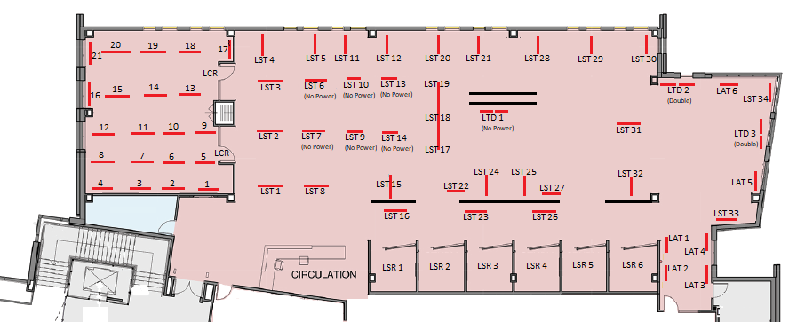

Library Class Room (LCR) – 21 Single Occupancy Tables
Library Study Rooms (LSR) – 6 Single Occupancy Tables
Library Study Tables (LST) – 34 Single Occupancy Tables (6 with no power source nearby)
Library Study Tables Double (LTD) – 3 Double Occupancy Tables (1 with no power source nearby)
Library Study Arm Table (LAT) – 6 Single Occupancy Chairs with Arm Table

